Lab 0

Note : All joint angles are in radians

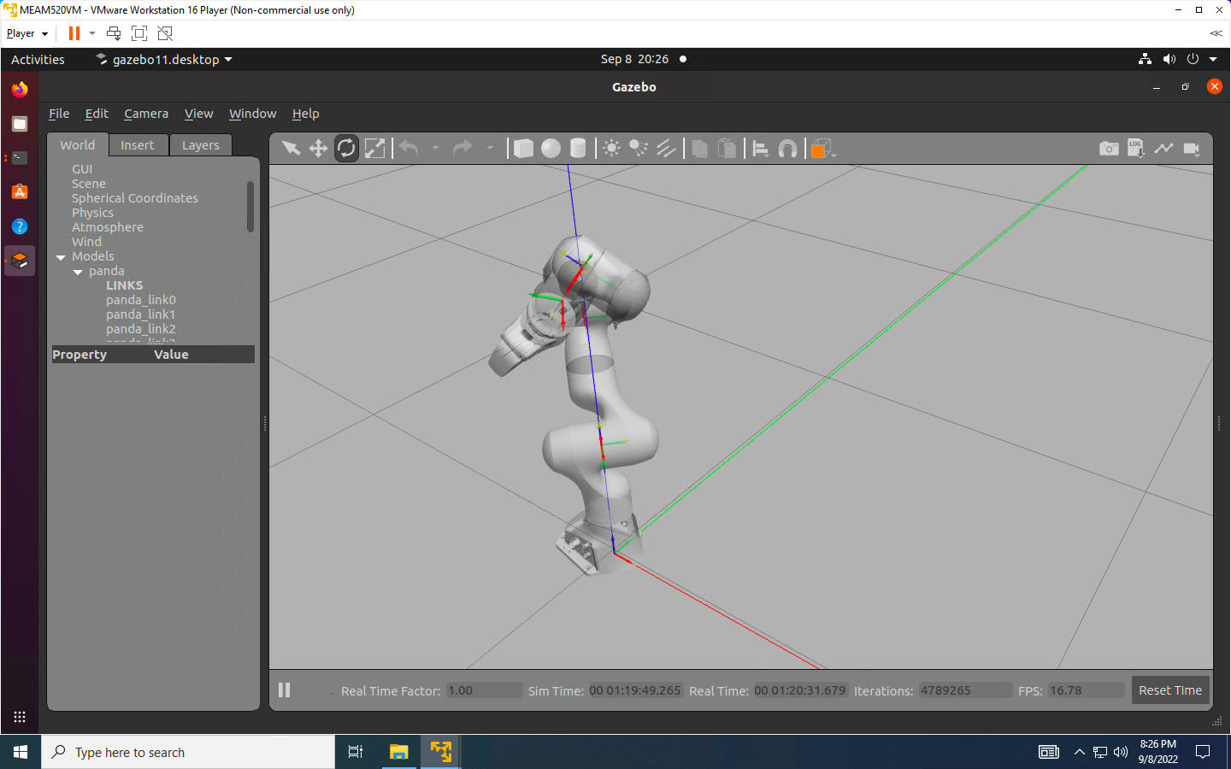

[-1, -1, 0, -2, -1, -1, -1]

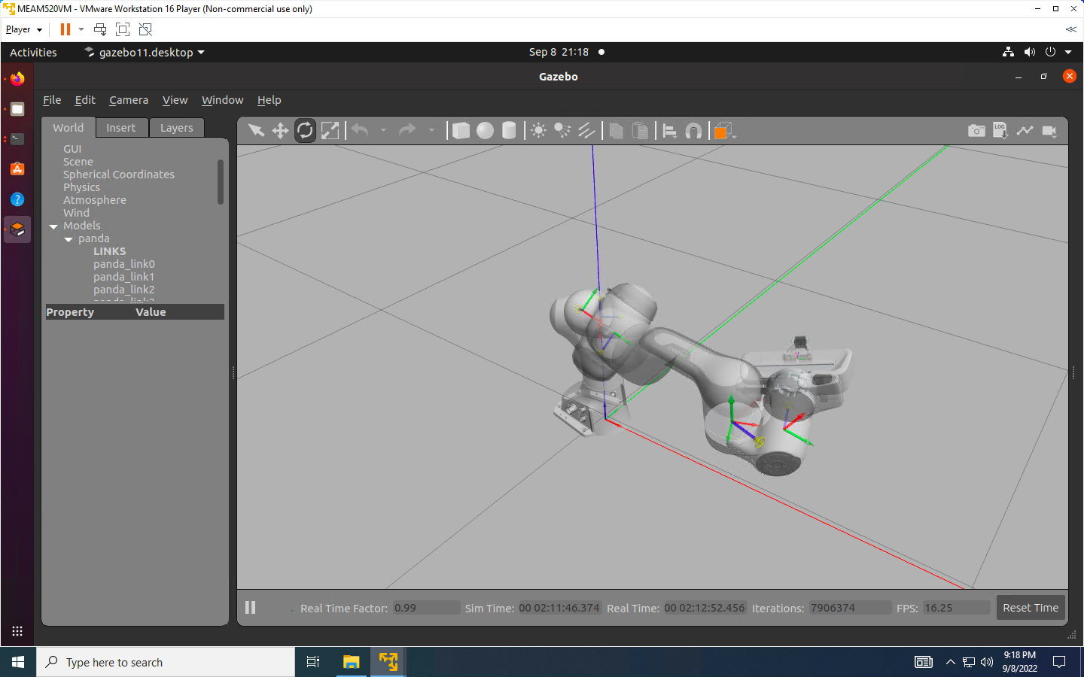

[-1, 1, 1, -1, 1, 1, -1]

[0, 1, 0, 1, 0, 1, 0]

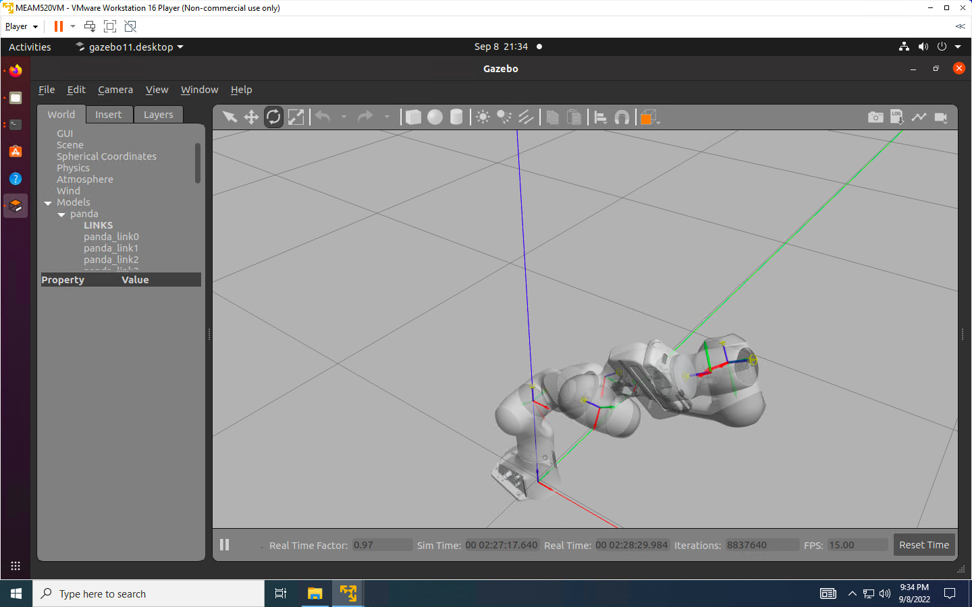

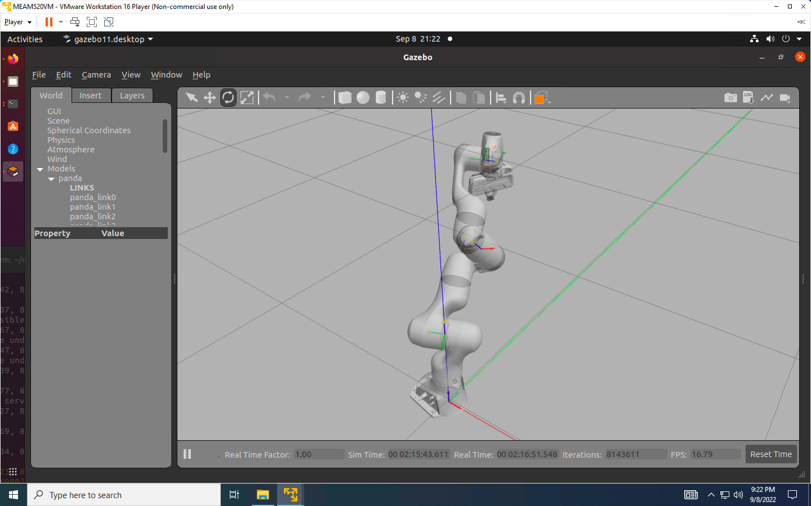 [0, 1, -1, 0, -1, 0, 0]

[2, 1, -2, 1, 2, 1, 0]